. What is a dictionary?

. An object-oriented data structure

. Similar to a hash table in Java

. Composed of key-value pairs

. Relationship: the key is used to access the value

. Difference in behavior between python 2.7.13 & 3.6.0

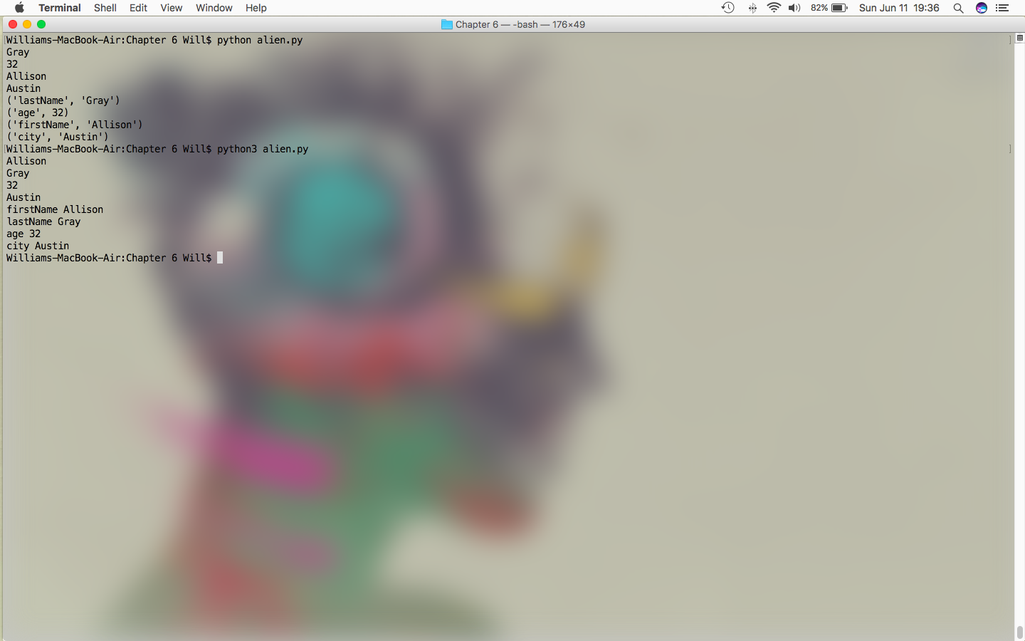

. Accessing data in dictionaries

. dict.items()

. pulls the pair out

. dict.keys()

. pulls the keys out

. dict.values()

. pulls the values out

. For slicing a list:

. [:n]

. Stops at the index n - 1

. Indices start at [0], so if slicing from [n1] to [n2]:

. n1 = actual index offset by - 1

. n2 = actual index offset by + 1